Sentiment Analysis of Indian Political Tweets using NLP Concerning General Election in India
Abstract: Natural language processing (NLP) is a well-known branch of artificial intelligence (AI) that extracts features of concern from raw information in plain text format. In the last two decades, research in NLP has gained exceptional advancement with the rapid growth of social media users. The text posted on different social media has become the source for research on Sentiment Analysis (SA). In this research, we explore the applications of NLP with a different context for SA. Python programming is used for procurement, data preprocessing, tweet analysis, and finally SA is performed based on different approaches of NLP. Tweets were collected between the years 2022 to 2023. Using these tweets, emotion detection or SA performed to find the opinion polarity of the individuals concerning general elections that were held in India in the year 2024. Three major political parties were considered for this study.

Keywords: Tweet Analysis, Sentiment Analysis, Opinion Mining, NLTK, Emotion detection
1. Introduction: This is a fact that most of the data especially in the form of text which is collected daily all over social media or on other platforms are unstructured means they do not have any predefined standard, whereas a very small percentage approximately 21% of the total data are structured in nature. Social media sites are one the major sources of such unstructured data. Recently text mining, emotion detection or SA become very popular due to the accessibility of a pool of data in various numbers of social media sites. Twitter is one of such popular micro-blogging sites since it has a huge amount of opinionated data [22]. The SA is a method of finding out the meaning in a portion of text, whether positive, negative, or neutral. This is also famed as Opinion Mining. The main purpose of SA or Opinion Mining is to find out the opinions of people’s emotions, attitudes, behaviors, or beliefs regarding any entity like products, events, topics, persons, or organizations. The SA has now become a versatile research field that is based on the techniques of NLP, Text Mining (TM), and Machine Learning (ML) [3] [10]. This helps the data analysts for large enterprises to determine public opinion, conduct market analysis, monitor the brand and the product status, and understand the customer’s experiences. User interest and reliance on online advice and recommendations have attracted researchers in this area. This should examine people's thoughts and find more details on them leading to the emergence of SA or Opinion Mining. The Web is used as a platform to enhance public opinion as well as to analyze responses to a particular topic from people all over the world with the help of social media, Blogs, Caucus, Forums, etc. The analysis aims to categorize or differentiate the user's conflicting feelings and to extract ideas related to the interested business.

  - Contributions
In this research paper, our contributions are as follows:
    - We used an effective approach to analyze and compare the sentiments of the text of Twitter data based on Indian Politics.
    - We collected the data which is raw and performed data preprocessing before analyzing the collected corpus. This is followed by sentiment analysis.
    - We performed the experiments to find the sentiments with different lexicon tools of NLP.
    - The experiments were performed on real-life tweets to establish that our approach is precious and can be implemented on similar applications for text mining or opinion mining.

1.2 Organization of the paper
There are five sections in this research paper. Section 1 is the Introduction part. In section 2 an overview of social media, sentiment analysis, text mining, and the NLP toolkit is provided. Section 3, describes the previous works done on sentiment analysis and NLP. Section 4 describes the approach and design methodology. Implementations and Results are discussed in Section 5. Finally, in Section 6, we have concluded the work.

2. Online platform the social media
Social media refers to online platforms and tools that enable people to create, share, and interact with content and with each other [20][22]. These platforms are designed to facilitate communication, networking, and the exchange of information among users. Popular social media platforms are Facebook, Twitter, Instagram, LinkedIn, TikTok, YouTube, etc. It has a significant impact on various aspects of society, including communication, marketing, politics, and culture. Lots of reviews or opinions about various topics are shared by users daily all over the world on this platform. This can be used to improve various aspects of life if it is refined and processed properly.

2.1 Sentiment Analysis on Tweets
Sentiment analysis, also known as opinion mining, is the process of using NLP, text analysis, and computational linguistics to identify and extract subjective information from text data. The primary goal is to determine the sentiment or emotion expressed in a piece of text, which can be classified as positive, negative, or neutral [4][13]. This technique is widely used in various applications such as market research, customer feedback analysis, social media monitoring, and more. Key aspects of sentiment analysis include Text Preprocessing, Tokenization, Feature Extraction, and Classification. Various approaches for Sentiment Analysis are Lexicon-Based Methods, Machine Learning-Based Methods, and Hybrid Methods that combine lexicon-based and machine-learning approaches to leverage the strengths of both [16] [17]. Several applications of Sentiment Analysis are Customer Feedback, Social Media Monitoring, Market Research, Political Analysis, and Content Moderation. Sentiment Analysis faces some challenges that are Sarcasm and Irony, Context and Ambiguity, Domain-Specific Language, Multilingual Analysis, etc. Overall, sentiment analysis is a powerful tool for extracting valuable insights from text data, but it requires careful consideration of context and linguistic nuances to achieve accurate results.

2.2 Text mining
Text mining, also known as text data mining or text analytics, is the process of deriving meaningful information and patterns from large volumes of unstructured text data. It involves various techniques and methodologies from NLP, machine learning, and data mining to transform text into structured data for analysis [22]. The key steps involved in Text Mining are Text Preprocessing, which involves Tokenization, Stemming and Lemmatization, Stop Word Removal, Lowercasing, Noise Removal.
Text Representation involves Bag of Words (BoW), Term Frequency-Inverse Document Frequency (TF-IDF), Word Embeddings, and Document Embeddings.
Text Mining Techniques involve Information Extraction, Topic Modeling, Sentiment Analysis, Text Classification, Clustering, and Named Entity Recognition (NER) within the text.
Visualization and Interpretation involve Word Clouds, Topic Visualizations, and Sentiment Trends.
Text mining transforms unstructured text into structured data, enabling more effective analysis and decision-making in various fields. It requires a combination of computational techniques and domain expertise to handle the complexities and nuances of natural language. Several applications of Text Mining are customer feedback analysis, healthcare, finance, legal, marketing and advertising, academic research, etc.

2.3 NLTK
NLTK, or the Natural Language Toolkit, is a comprehensive library in Python for working with human language data (text). It provides tools for various aspects of NLP, including tokenization, stemming, parsing, tagging, and semantic reasoning. NLTK is widely used in both academia and industry for research, education, and practical applications in text processing and analysis [7] [21].

3. Related work:
NLP is a well-known branch of AI and has recently accomplished much attention for the computational representation and analysis of human languages. Many researchers used several different methodologies for SA with the use of NLP.
In [5] the authors distinguished NLP discussion in several phases as various levels of NLP, history, and evolution of NLP, important features of Natural Language Generation (NLG), and various applications, recent trends, and challenges faced by NLP. The discussion was based on different datasets, various models, and several evaluation metrics in NLP. Some of the common challenges that NLP may face mentioned by the authors like, Contextual words and different phrases, Sarcasm, and irony.
In [15], the author described the future of NLP and the growth of the NLP market. According to him, there have been two major advances, one in 2017 and the other in 2019, in the improvement of NLP. In 2017, a model called Transformer, a new form of Deep Learning (DL), effectively parallelized Machine Learning (ML) training, which improved accuracy. In 2019, Google introduced Bidirectional Encoder Representations from Transformers (BERT) that improves the performance of the Transformer model. These two advances intended that NLP can easily outperform normal people in several tasks. The transfer models such as GPT-3 developed by open AI are also discussed. In the future NLP will involve dialog models and conventional AI systems.
In [11] the authors discussed the pre-trained models used for sentiment classification. Extracting the polarity from the collected dataset in SA becomes a challenging issue. Pre-trained models could easily accomplish the task without building a new model. Various pre-trained models such as Google BERT, Transformer, OpenAI GPT-2, BiGRU, ULMFiT, Transformer-XL, and XLNet are introduced in their paper.
The authors present basic experiments on tweets for SA [20]. Their experiment was modeled to acquire sentiment depending on the themes present in the tweets. Using NLP techniques, it identifies the sentiment that is related to a particular subject. For sentiment classification, their experiment was based on three main categories, and these are subjectivity classification, polarity classification, and semantic association. Their experiment used sentiment lexicons and subsequently defined a grammatical relationship between sentiment lexicons and the subject. The results of the experiments reveal that their proposed system performs better than the current text SA tools.
In [12] the authors present a consistent and systematic survey of NLP robustness research. They identified various dissimilarities in the literature. They found that newly developed techniques must address false association issues. Overall, they expect that their research work will provide new guidelines for the researchers. That will inspire further interest in NLP and work in addressing various research gaps.
The authors reviewed several NLP methods and the most functional NLP toolkits that deal with Chinese word tokenization as well as segmentation [21]. Further, the opinions of mining and SA were also reviewed. In this review, it was found that a large number of NLP methods exist for SA and opinion mining. To process the meaning of a given text the mining could be categorized into three dimensions, and these are document level, sentence level, and fine-grained level. According to the authors, modification of NLP backhand techniques is necessary.
In [3] the authors suggested a methodology to identify and infer the real-time events that occur in the context of smart cities. This document presents a structure for identifying events and analyzing the satisfaction of the residents in a smart city in terms of their emotional tendencies. They also propose a system that will carry out citizen satisfaction analysis. In addition, they expose and authenticate the relationships between citizen satisfaction, co-occurring events, and ecological factors. Also, they authenticate the relationships with the help of Multiple Regression Analysis (MRA) one of the statistical models.
In [1] the authors discussed the various prevailing theories that underlie the field of NLP and their use to collect user sentiments on social media. They also look at some of the applications of SA and the use of NLP in mental health. The NLTK toolkit was executed in diverse NLP theories and the data scavenging process was also discussed. A detailed overview of NLP and SA were also discussed. In addition, a brief overview of the power of Python programming and the NLTK toolkit was discussed. Finally, they presented various applications of SA and the use of NLP in the field of medical science. In the future, the author wants to implement SA for detecting mental health diseases like cyberbullying and depression.
In [14] the authors proposed an NLP-based technique to improve the classification of sentiment with semantics to feature vectors, and by using an ensemble method in classifying the sentiments. Their proposed system will collect data from Twitter and use NLP techniques for extracting features from these collected tweets, simultaneously, Word Sense Disambiguation (WSD) and WordNet synsets are also included in the feature vector. For classifying the sentiment as Positive, Negative, or Neutral and to improve the prediction accuracy several Ensemble approaches of classification are used. They concluded that in the future the computational cost of the feature vector size will be calculated and the for classifying the sentiment paragraph level context may also be considered.
In [13] the authors surveyed and proposed a new system to detect sentiments of customers review for online shopping. During the COVID-19 pandemic, service providers in online product service make it enhanced for people. More than 1000 data were collected and the product reviews of these collected data in the Bangla language were analyzed. They aimed to design a system for analyzing the feedback of customers. With the help of NLP, the ratio of positive as well as negative feedback from online shoppers and the feedback from earlier customers are analyzed. They performed SA with KNN, Decision Tree, Support Vector Machine (SVM), Logistic Regression and Random Forest classification algorithms. It was observed that SVM has a maximum accuracy of 88.81% compared to all other algorithms. In the future, they aim to develop a global browser that will analyze a particular webpage for real-time reviews and comments on previous customers’ sentiments.

4. Approach and Design Methodology

4.1 Collection of Tweets:
Three Excel files are used for three major political parties of India Party 1, Party 2, and Party 3 that contain the relevant tweets. These tweets are preprocessed before analyzing the sentiments within them. The tweets contain much punctuation, URLs, HTML tags, emojis, and many more symbols that are irrelevant. With the help of Python code and library, the following tasks are done in data preprocessing. Removal of punctuation marks, URLs, HTMS tags, emojis, Numbers, and Case folding.

4.2. Cleaning of tweets and collected relevant Data.
The entire data set contains almost 50k plus tweets of different topics like
- Political (both National and International tweets),
- Sports,
- Movie,
- Medical and many other topics

4.2.1 Making Sure Data is Complete
We checked if any information was missing in our data and fixed these parts. Organized Tweets as per Political parties. We sorted tweets for each politician using special keywords by making use of regular expressions. This helped us group the tweets correctly.
A function clean_tweet is defined to clean the tweet text. It removes URLs, user mentions, hashtags, and non-alphanumeric characters, and converts the text to lowercase. This function is applied to the 'Tweet' column of each politician-specific dataframe.
The next step was to clean the collected Tweets. For this, we removed website links, URLs, mentions of people, hashtags, and strange characters that as emojis, etc. from the tweets using Regular Expressions. Removing Useless Words: We made a list of common words (like &#39;the&#39;, &#39;is&#39;, etc.) that have no use and took them out of the tweets. This made the tweets cleaner and easier to understand.
To make the tweets uniform, we converted all the text in the tweets to lowercase. This helps when we analyze the tweets later.

4.2.2 Change tweets into numbers
The TfidfVectorizer tool (tf-idf vectorization) helps us turn the words in tweets into numbers. This tool helps us focus on the important words and ignore common words, which is useful for understanding the tweets better.

TF-IDF Vectorizer and Count Vectorizer:
TF-IDF is the abbreviation of the Term Frequency-Inverse Document Frequency. TF-IDF vectorizer is a technique to convert textual data into numerical vectors and is used in NLP, which can be further used as input for machine learning models. This is commonly used in information retrieval and text mining as a way to convert text into a meaningful representation for machine learning algorithms, such as clustering, classification, and relevance ranking. In Python, we can implement TF-IDF vectorization using libraries such as scikit-learn (TfidfVectorizer class), which handles the computation efficiently and provides options for pre-processing and feature selection.
Count Vectorizer is another technique used in NLP to convert text data into numerical vectors. Unlike TF-IDF vectorizer, which considers both the frequency of terms in a document and their rarity across documents, whereas, Count Vectorizer simply counts the occurrences of each word in a document. Tokenization, counting, and vector representation are the basic tasks of Count Vectorizer. Count Vectorizer is a fundamental step in creating a Bag of Words model, where the order of words is disregarded and only their frequency counts matter. This takes a corpus of documents as input and provides a matrix as output where each row represents a document and each column represents a token (word). The matrix elements are the counts (frequencies) of each token in each document. Count Vectorizer is easy to implement. In Python, we can use libraries such as scikit-learn (CountVectorizer class) to perform Count Vectorization. It is often used as a pre-processing step before applying machine learning algorithms that require numerical input, such as classifiers or clustering algorithms.

In our corpuses, we used <210000x40187 sparse matrix of type '<class 'numpy.float64'>' with 2863980 stored elements in Compressed Sparse Row format>. The result of the Sparse Matrix is shown in Figure 1.

(0, 24248) 0.6914596654147596 |  | (209998, 34251) 0.2572919330986098
(0, 25159) 0.7224150684367738 |  | (209999, 17576) 0.34717719581197476
(1, 28229) 0.1540537073391477 |  | (209999, 9714) 0.34717719581197476
(1, 32769) 0.3729839977874449 |  | (209999, 39219) 0.2679618378861302
(1, 12147) 0.27445293257754855 |  | (209999, 9772) 0.23698572520103803
(1, 31015) 0.5138482383508354 |  | (209999, 38862) 0.22321614236085247
(1, 39493) 0.1843147540512144 |  | (209999, 27575) 0.20331229838734144
(1, 7483) 0.31750085387382954 |  | (209999, 24392) 0.21042024971564954
(1, 22857) 0.37211628256859614 |  | (209999, 23699) 0.21160300463100376
(1, 6494) 0.33160882135305064 |  | (209999, 22108) 0.2250688310662685
(1, 742) 0.3050364630548592 |  | (209999, 14051) 0.2431768456237799
(1, 24248) 0.10144697331106431 |  | (209999, 2343) 0.200316001320142
(1, 25159) 0.1059885714711303 |  | (209999, 15564) 0.16272060516523704
(2, 35187) 0.15794112252426049 |  | (209999, 4919) 0.15389111708444142
(2, 17635) 0.23002850397841798 |  | (209999, 14002) 0.18274383831822086
(2, 17970) 0.2045439416075876 |  | (209999, 32783) 0.182717378067155
(2, 3845) 0.2668785870340756 |  | (209999, 26603) 0.14763951256020963
(2, 14947) 0.1769607213099223 |  | (209999, 13946) 0.22728859548314695
(2, 9907) 0.12600167619887903 |  | (209999, 29428) 0.1538615149848748
(2, 17281) 0.22942760263179754 |  | (209999, 20245) 0.06139293497871195
(2, 1658) 0.20022160212758205 |  | (209999, 3230) 0.06179397662374784
(2, 39440) 0.11375292766402581 |  | (209999, 1139) 0.11130192872155738
(2, 14657) 0.17789504816603624 |  | (209999, 38044) 0.05131905327157311
(2, 11174) 0.21315588787403378 |  | (209999, 11714) 0.18517139353199114
(2, 14782) 0.2513770534351486 |  | (209999, 21183) 0.17282588057050713
(2, 14782) 0.2513770534351486 : : (209998, 34251) 0.2572919330986098
Figure 1. Result of Sparse Matrix

4.2.3 Creating Visuals from Words
We used Python’s WordCloud to make pictures that show the most important words in the tweets. These pictures help us see the main topics in the tweets easily. The most significant words are selected and a word cloud is generated to visually represent these words for the three political parties. The results of WordCloud of these parties are shown in Figure 2.

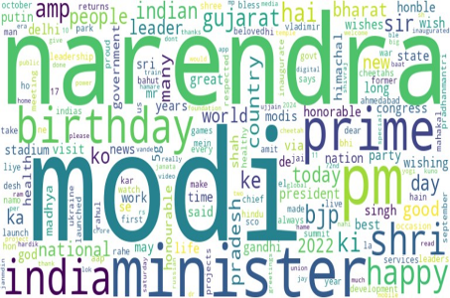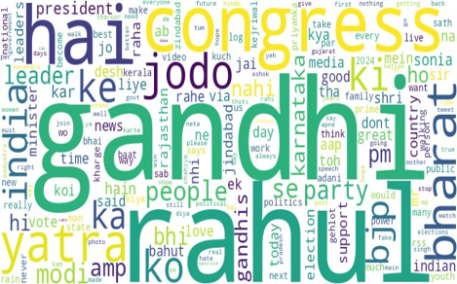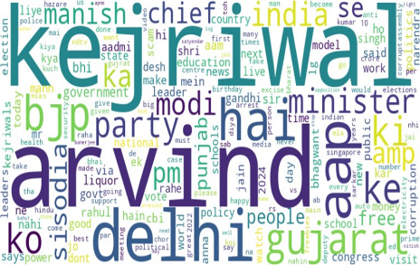
WordCloud Political Party 1 WordCloud Political Party 2 WordCloud Political Party 3
Figure 2. WordCloud of Three Political Parties

5. Analyzing Feelings and Emotions in Tweets
Our next step was to analyze the feelings and emotions in the tweets. We used NLTK’s Vader lexicon, TextBlob, and SentiWordNet for this.
Vader lexicon is used for sentiment analysis and 'punkt' is for tokenizing sentences. Functions are defined to compute sentiment and emotion scores using Vader and NRCLex, respectively. The Vader lexicon, also known as the Vader Sentiment Lexicon, is a lexicon and rule-based sentiment analysis tool specifically designed for analyzing sentiments expressed in social media texts. "VADER" stands for "Valence Aware Dictionary and sEntiment Reasoner". It is included as part of the NLTK library in Python.
TextBlob is a Python library for processing textual data. This provides an API for basic NLP tasks like part-of-speech tagging, noun phrase extraction, sentiment analysis, classification, translation, and more. This is built on top of NLTK and Pattern, another NLP library for Python. It is designed to provide a beginner-friendly interface for performing various NLP tasks without needing extensive knowledge of NLP algorithms and is easy to use.
SentiWordNet is a lexical resource explicitly designed for opinion mining and sentiment analysis. It is an extension of the WordNet lexical database, where each synset (set of cognitive synonyms) in WordNet is assigned three sentiment scores: Positivity Score (indicates how positive the terms in the synset are), Negativity Score (indicates how negative the terms in the synset are) and Objectivity Score (indicates how objective (neutral) the terms in the synset are). These scores are assigned values between 0 and 1 and sum up to 1 for each synset. SentiWordNet allows users to look up words and their associated sentiment scores, aiding in the analysis of texts for sentiment. It is widely used in NLP applications to automatically determine the sentiment expressed in written language, such as in social media posts, reviews, and articles. Overall, SentiWordNet is a valuable resource for researchers and developers working on projects involving sentiment analysis and opinion mining.

5.1 Average of Sentiment score
Here we used the function aggregate that calculates the average of positive, negative, and neutral, sentiment scores for each political party's dataframe. We used a tool to find out if the tweets were positive, negative, or neutral. This helps us understand how people feel about each politician.
Following are the sentiment scores that we achieved after analyzing the tweets with three different lexicons of NLP. The result shows that the political Party 1 has the highest positive score (0.174327, 0.213368, and 0.055022 for Vader, TextBlob, and SentiWordNet respectively) compared to the political Party 2 (0.118240, 0.116741, and 0.025727 for Vader, TextBlob and SentiWordNet respectively) and the political Party 3 (0.105134, 0.100721 and 0.027917 for Vader, TextBlob and SentiWordNet respectively). Also, Party 1 has the lowest negative sentiment score compared to the other two big parties. The result is shown below:

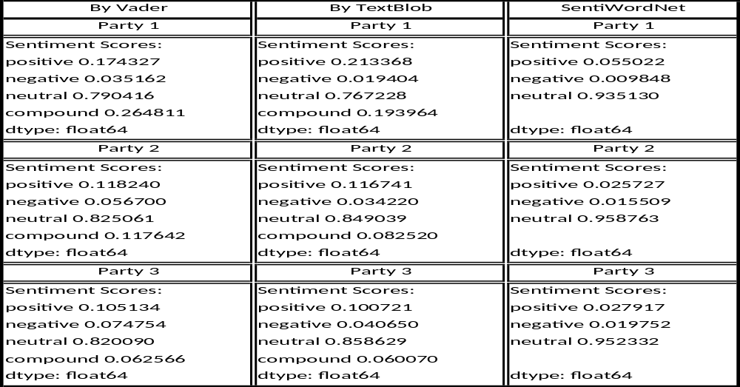

Table 1 Comparison of Sentiment Score for the three methods
5.2 Understanding Emotions with NRCLex:
This tool helps us see different emotions like happiness or anger in the tweets. This gives us a more detailed view of how people feel. The function aggregate_emotions computes the average of each emotion across all tweets for each party. Figure 3 shows the overall sentiment scores achieved by the three political parties using three techniques of NLP.

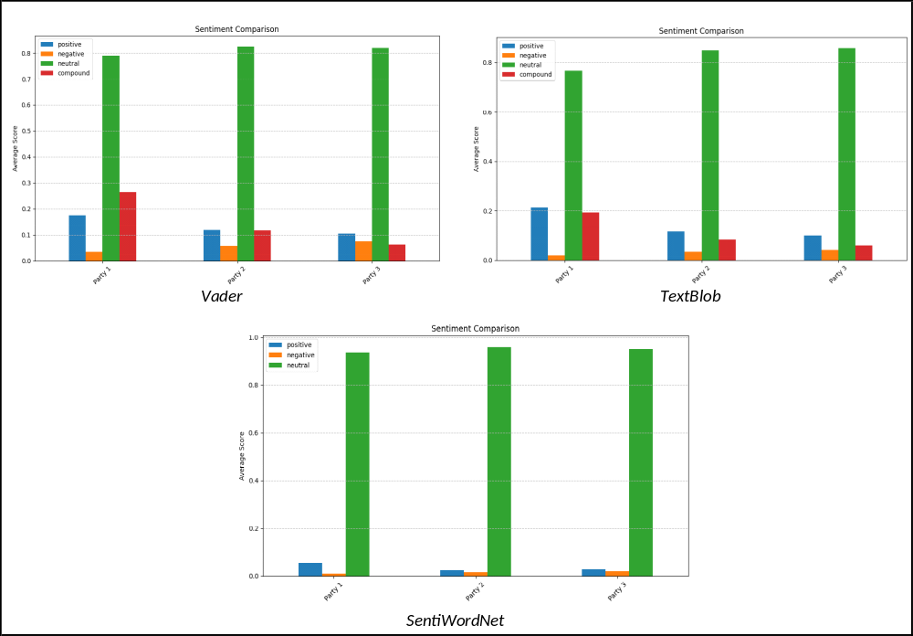
Figure 3 Visualization of Sentiment Score of all three political parties
Figure 4 to Figure 6 shows various emotions for different political parties separately. Different emotions like fear, anger, anticipation, trust, surprise, positive, negative, sadness, disgust, and Joy are defined. This reveals that positive emotion compared to negative emotion is much better for Party 1 than the other two political parties.

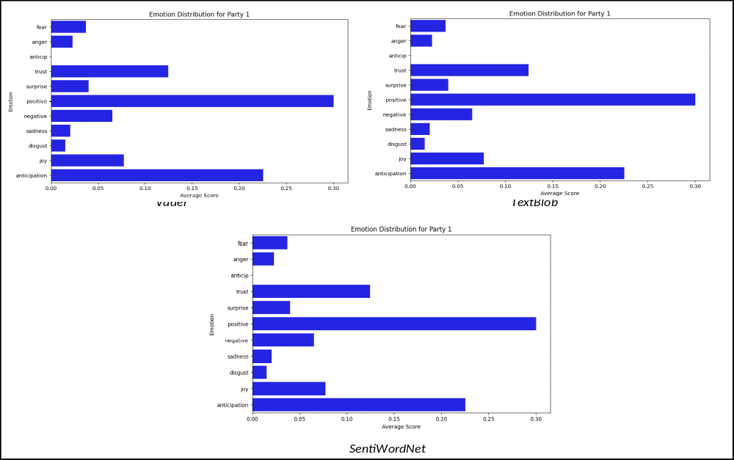
Figure 4 Emotion Distributions for the Party 1

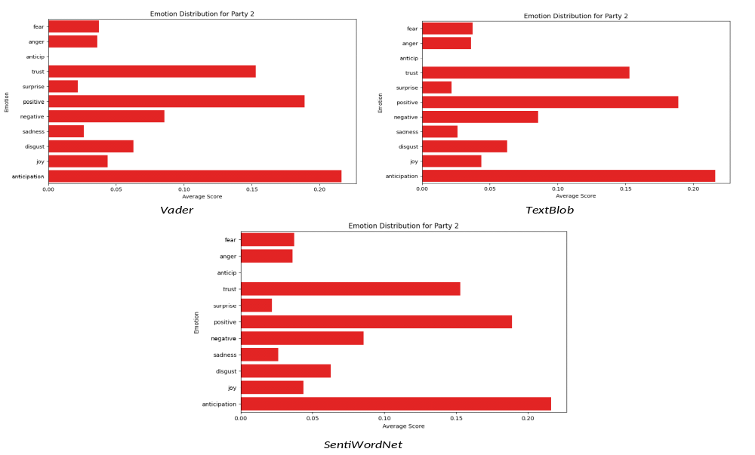

Figure 5 Emotion Distribution for the Party 2
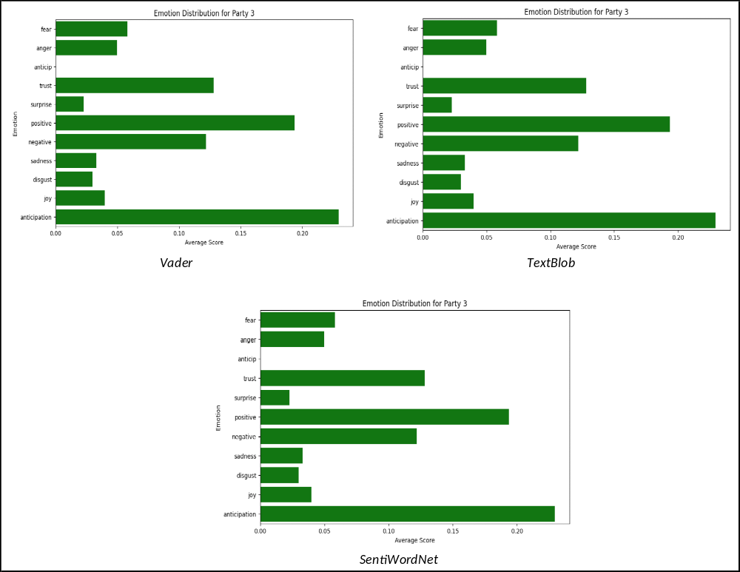

Figure 6 Emotion Distributions for the Party 3

In Figure 7, we tried to compare the emotions of these three parties for different NLP techniques in one place. The colors tell us how much of each emotion is being talked about in tweets related to these parties.
Blue color means less emotion and red color means a lot of emotion is there in the tweets. The numbers tell us exactly how much of an emotion is there, high numbers reveal a lot of emotion and low number means that a particular emotion is not as much as it is being talked about.
For example, we can see the positive emotion score for Party 1 is 0.30 which is very high; this infers that positive emotion expressed in the tweets about Party 1 contributes to 30% of the emotional content. The positive emotion score for Party 2 and Party 3 is 0.19 which is very low; this infers that positive emotion expressed in the tweets about Party 2 and Party 3 contributes to 19% of the emotional content.
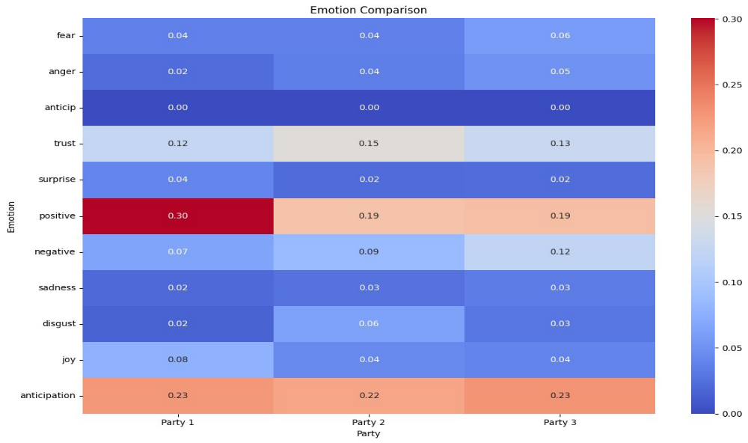
Figure 7 Emotion Comparisons
6. Conclusion:
In this research, we analyze the tweets before making an inference. The data used in this research are original and sufficiently large. The tools used in this research are based on a comprehensive literature review. We know that the tweet has no precise format; however, there is a limit to the text length. Initially, it was 140 characters but now it has been extended up to 240 characters. Tweets were collected from a public dataset; hence no sentiment labels are contained in it. The noisy nature of the tweets and the absence of sentiment labels make it complex in this research. Three tools of NLP are used to find the sentiment analysis like Vader, TextBlob, and SentiWordNet using Python programming. The tweets contain a variety of views as these were collected at different points in time. Almost the same results are obtained with very slight differences, implying that the output obtained is valid. After analyzing the result, it was concluded that a particular political party is more popular than the other two big political parties.
The result of the general election obtained in June 2024 completely compliance with the results obtained in the experiment with the collected tweets. This reveals that our approach applied in this research for performing sentiment analysis was appropriate.
The scope of this research is limited only to the textual data obtained from Twitter. In future data like images, audio, online articles, multimedia, etc. can be included in the dataset. In the future, all these characteristics will be considered.

Declarations:
“All authors declare that they have no conflicts of interest”

References:
[1] Adil Rajput (2019), Natural Language Processing, Sentiment Analysis and Clinical Analytics. Computer Science, Computation and Language, arXiv:1902.00679 [cs.CL].
[2] Amirsina Torfi et al. (2020), Natural Language Processing Advancements By Deep Learning: A Survey. https://www.researchgate.net/publication/339675100.
[3] Andrei Hodorog, Ioan Petri, and Yacine Rezgui (2022), Machine learning and Natural Language Processing of social media data for event detection in smart cities, Sustainable Cities and Society 85, 104026.
[4] Cagla Balli, Mehmet Serdar Guzel, Erkan Bostanci, and Alok Mishra (2022), Sentimental Analysis of Twitter Users from Turkish Content with Natural Language Processing, Hindawi Computational Intelligence and Neuroscience, Article ID 2455160, 17 pages https://doi.org/10.1155/2022/2455160.
[5] Diksha Khurana, Aditya Koli, Kiran Khatter, and Sukhdev Singh (2022), Natural language processing: state of the art, current trends and challenges,Ⓒ The Author(s), under exclusive license to Springer Science+Business Media, LLC, part of Springer Nature.
[6] Dinuka Sahabandu, and Sukarno Mertoguno (2022), A Natural Language Processing Approach for Instruction Set Architecture Identification, arXiv:2204.06624v1 [cs.CR].
[7] Ivano Lauriola, Alberto Lavelli, and Fabio Aiolli (2021), An introduction to Deep Learning in Natural Language Processing: Models, techniques, and tools..
[8] Jie Yang, Soyeon Caren Han, and·Josiah Poon (2021), A Survey on Extraction of Causal Relations from Natural Language Text, arXiv:2101.06426v2 [cs.IR].
[9] Julia El Zini and Mariette Awad (2022), On the Explainability of Natural Language Processing Deep Models, permissions@acm.org., © 2022 Association for Computing Machinery. 0360-0300/2022/7-ART $15.00, https://doi.org/10.1145/3529755.
[10] Kai Jiang, and Xi Lu (2020), Natural Language Processing and Its Applications in Machine Translation: A Diachronic Review, IEEE 3rd International Conference of Safe Production and Informatization (IICSPI) | 978-1-7281-7738-0/20/$31.00 IEEE | DOI: 10.1109/IICSPI51290.2020.9332458.
[11] Leeja Mathew, and Bindu V R (2020), A Review of Natural Language Processing Techniques for Sentiment Analysis using Pre-trained Models, Fourth International Conference on Computing Methodologies and Communication (ICCMC) 978-1-7281-4889-2/20/$31.00, IEEE 10.1109/ICCMC48092.2020.ICCMC-00064.
[12] Marwan Omar, Soohyeon Choi, DaeHun Nyang, and David Mohaisen (2022), Robust Natural Language Processing: Recent Advances, Challenges, and Future Directions, arXiv:2201.00768v1 [cs.CL].
[13] Minhajul Abedin Shafin et al (2020), Product Review Sentiment Analysis by Using NLP and Machine Learning in Bangla Language, International Conference on Computer and Information Technology (ICCIT).
[14] Monisha Kanakaraj and Ram Mohana Reddy Guddeti (2015), NLP Based Sentiment Analysis on Twitter Data Using Ensemble Classifiers, 3rd International Conference on Signal Processing, Communication and Networking (ICSCN).
[15] Narendran Thillaisthanam (2021), The Future of Natural Language Processing is Bright | ITBE
[16] Nhan Cach Dang, María N. Moreno-García, and Fernando De la Prieta (2020), Sentiment Analysis Based on Deep Learning: A Comparative Study, Electronics, 483; doi:10.3390/electronics9030483.
[17] Shilpa P C, Rissa Shereen, Susmi Jacob, and Vinod P (2021), Sentiment Analysis using Deep learning, Third International Conference on Intelligent Communication Technologies and Virtual Mobile Networks (ICICV) | 978-1-6654-1960-4/20/$31.00 IEEE | DOI: 10.1109/ICICV50876.2021.9388382.
18] Tanya Nijhawan, Girija Attigeri, and T, Ananthakrishna (n.d), Stress detection using natural language processing and machine learning over social interactions, https://doi.org/10.1186/s40537-022-00575-6.
[19] Tetsuya Nasukawa, and Jeonghee Yi (2003), Sentiment Analysis Capturing Favorability Using Natural Language Processing, K-CAP’03, Sanibel Island, Florida, USA. ACM 1-58113-583-1/03/0010…$5.00.
[20] Wei Yen Chong, Bhawani Selvaretnam, and Lay-Ki Soon (2014), Natural Language Processing for Sentiment Analysis An Exploratory Analysis on Tweets, 4th International Conference on Artificial Intelligence with Applications in Engineering and Technology 978-1-4799-7910-3/14 $31.00, IEEE DOI 10.1109/ICAIET.2014.43.
[21] Yasir Ali Solangi et al (2018), Review on Natural Language Processing (NLP) and Its Toolkits for Opinion Mining and Sentiment Analysis, Conference Paper, IEEE 5th International Conference on Engineering Technologies & Applied Sciences, Bangkok Thailand.
[22] Younis, Eman MG. (2015) "Sentiment analysis and text mining for social media microblogs using open source tools: an empirical study." International Journal of Computer Applications, 112(5) :0975 – 8887.
[23] Zulfadzli Drus, and Haliyana Khalid (2019), Sentiment Analysis in Social Media and Its Application: Systematic Literature Review, 1877-0509. The Authors. Published by Elsevier B.V. (http://creativecommons.org/licenses/by-nc-nd/4.0/), Peer-review under responsibility of the scientific committee of The Fifth Information Systems International Conference. 10.1016/j.procs.2019.11.174.

